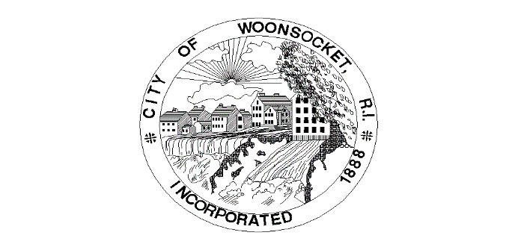
Grant Name | Issuing Organization | Amount | Date | Grant Use
Rebuilding American Infrastructure with Sustainability and Equity | DOT | $24,062,047.86 | 4/14/2022 | Downtown Transit Corridor
PeopleForBikes Grant | PeopleForBikes | $3,000.00 | 10/5/2022 | Bike repair station
RI Rebounds: Outdoor & Public Space Capital Improvement Grant | RI Commerce | $100,000.00 | 3/24/2022 | WWII Park "zoo"

