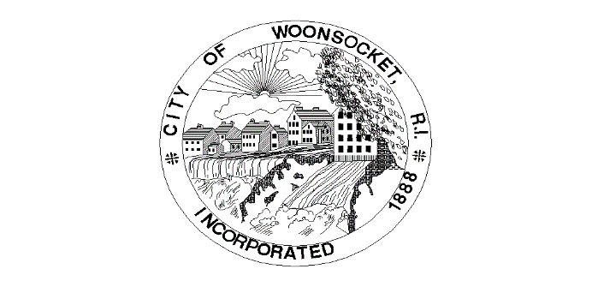
Grant Name | Issuing Organization | Amount | Date | Grant Use
Urban & Community Forestry Grant Program | RIDEM | $12,550.00 | 3/24/2023 | Billboards with RiverzEdge
2023 Rhode Island Site Readiness Grant Program | RI Commerce | $0.00 | 3/29/2023 | Pre-development activities for public safety complex
2023 Rhode Island Site Readiness Grant Program | RI Commerce | $0.00 | 3/28/2023 | Pre-development activities for Mendon Rd. housing development
Hometown Grant Program | T-Mobile | $50,000.00 | 3/27/2023 | Woonsocket animal sculptures (Zoo)
Rebuilding American Infrastructure with Sustainability and Equity | DOT | $24,443,036.46 | 4/13/2023 | Downtown Transit Corridor
Lead Hazard Reduction Grant Program | HUD | $4,000,000.00 | 6/26/2023 | Woonsocket Lead Hazard Reduction Program
RAISE | US DOT | $24,810,668.00 | 2/22/2023 | Pedestrian upgrades and various traffic related upgrades to Downtown
Animal Welfare Grant | RI Foundation | $55,000.00 | 6/6/2023 | Animal shelter engineering and rabies clinic

