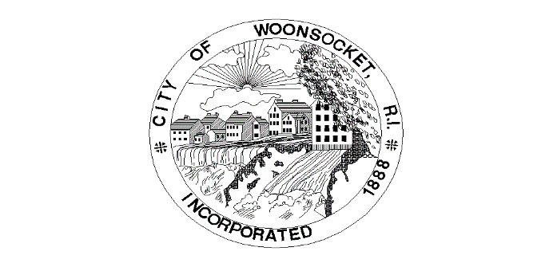
Grant Name | Issuing Organization | Amount | Date | Grant Use
Asphalt Art Initiative | Bloomberg Philanthriopies | $25,000 | 6/12/2023 | 3-D crosswalks
Urban & Community Forestry Inflation Reduction Act Grant | USDA | $100,000 | 5/31/2023 | Trees at Cass Park
Congressionally Directed Spending | Office of Senator Whitehouse | 10,000,000 | 3/9/2023 | Public safety complex
Congressionally Directed Spending | Office of David Cicilline | 4,007,830 | 3/24/2023 | Cass Park multi-purpose center
Congressionally Directed Spending | Office of Jack Reed | 10,000,000 | 3/6/2023 | Public safety complex
SNEP-SOAR | EPA |  | 9/15/2023 | Cass Pond dredging and aerators
Walmart Grant | Walmart |  | Quarterly | Struggling artists, paint-by-number mural
Open Space Grant | RIDEM | $400,000 | 10/27/2023 | Pocket parks in Fairmount
T-Mobile Hometown Grant | T-Mobile | $31,500 | 9/12/2023 | Abraham Lincoln mural on Longley Building
Older Adult Home Modifications | HUD | $1,250,000 | 10/16/2023 | Older Adult Home Modifications
Healthy Homes Production | HUD | $2,000,000 | 11/7/2023 | Healthy Homes Production

